

FACULTY OF ENGINEERING & TECHNOLOGY

ASSIGNMENT REPORT OF COMPUTER PROGRAMMNIG USING MATLAB

PRESENTED TO
THE COMPUTER PROGRAMMING COURSE LECTURER
MR. MASERUKA BENDICTO

By GROUP 8

GROUP MEMBERS
NAMES | REG NUMBER | PROGRAM
ENYUKU PIUS | BU/UP/2025/4638 | BEM
MUGUSHA JOB | BU/UP/2025/05719 | BEM
RUBANGAKENE JONATHAN | BU/UP/2025/1994 | BEM
KISOLO OWEN SAM | BU/UP/2025/05873 | BEM
HAFIZAH KHADIJAH MUSA | BU/UP/2025/4608 | BEM

ABSTRACT
This report details a two-part MATLAB assignment focused on applying data handling and organization skills building from assignment one as we studied from module one to five during lecture time.
From question one of assignment 4, we were to apply digital image processing techniques in MATLAB

ACKNOWLEGEMENT
We thank God Almighty for the gift of life, love and wisdom throughout this course.
Also our gratitude goes to our course lecturer, Mr. Maseruka Bendicto for guiding us in this course that is a necessity in our engineering professions.
And lastly, appreciation goes to all our group members for the commitment and team spirit which simplified work and made it easy for us to complete the task and come up with this report.

DECLARATION
We, Group 8 members hereby declare that report is to the best of our knowledge and has been developed and written by us. It includes the details of the assignment and it has never been presented by any individual.
Group 8

NAMES | REG NUMBER | PROGRAM
ENYUKU PIUS | BU/UP/2025/4638 | BEM
MUGUSHA JOB | BU/UP/2025/05719 | BEM
RUBANGAKENE JONATHAN | BU/UP/2025/1994 | BEM
KISOLO OWEN SAM | BU/UP/2025/05873 | BEM
HAFIZAH KHADIJAH MUSA | BU/UP/2025/4608 | BEM

APPROVAL
This is to confirm that this report has been written and presented by Group 8, giving details of the assignment carried out.
Name ..............................................................................................................
Date ..................................................................................................................
Signature ........................................................................................................

TABLE OF CONTENT
ABSTRACT 3
ACKNOWLEGEMENT 4
DECLARATION 5
APPROVAL 6
Introduction 6
Chapter 2: SOLUTIONS 7
From question one 1: 7
Using the Dataset 7
Methodology 7
Chapter 3: 10
Conclusion and Learning Experience 10
Chapter 4: 11
References and Resources 11

Introduction
This report gives a detailed overview of the MATLAB assignment built from the questions of assignment four showing use of the different MATLAB features from module one to module five . The exercise focused on data input and output , specifically the process of inputing a dataset , structuring it for analysis as it requires us a structural array

From question 1;
- Utilize all the knowledge obtained from module one to five to fully characterize the externl structural features studied in s4 biology including original photographs and show additional images processed with the techniques from matlab image processing onramp course.

Chapter 2: SOLUTIONS

From question one 1:

Using the Dataset
The primary objective of this exercise was to create a MATLAB script suitable for handling an external dataset. Our approach was a three-step process:

Methodology
Data Acquisition and processing
Using the already cleaned dataset
Our task was to come up with a MATLAB code that would return different skills as required.
Below is a list of the different skills we were able to apply in question one
- Data input
- Importing data
- Read leaf images into MATLAB
- Convert RGB leaf images into grayscale images
- Display the different stages of image processing

Below is a code that returns all the above skills.
leaves(1).name = 'hibiscus';
leaves(1).class = 'dicotyledon';
leaves(1).type = 'simple';
leaves(1).shape = 'ovate';
leaves(1).venation ='netted';
leaves(1).margin = 'serrated';
leaves(1).arrangement = 'alternate';
leaves(1).originalimage = imread('C:\Users\piuse\OneDrive\Desktop\group work\hibiscus.jpeg');
leaves(1).grayimage = rgb2gray(leaves(1).originalimage);
leaves(1).adjustedimage = imadjust(leaves(1).grayimage);
Threshold1 = graythresh(leaves(1).adjustedimage);
leaves(1).binarymask = imbinarize(leaves(1).adjustedimage, Threshold1);
leaves(1).edgeimage = edge(leaves(1).grayimage, 'canny');
leaves(2).name = 'cassava'
leaves(2).class = 'dicotyledon'
leaves(2).type = 'compound'
leaves(2).shape = 'palmatifid'
leaves(2).venation ='palmate reticulate'
leaves(2).margin = 'entire'
leaves(2).arrangement = 'alternate'
leaves(2).originalimage = imread('C:\Users\piuse\OneDrive\Desktop\group work\cassava.jpeg');
leaves(2).grayimage = rgb2gray(leaves(2).originalimage);
leaves(2).adjustedimage = imadjust(leaves(2).grayimage);
threshold2 = graythresh(leaves(2).adjustedimage);
leaves(2).binarymask = imbinarize(leaves(2).adjustedimage, threshold2);
leaves(2).edgeimage = edge(leaves(2).grayimage, 'canny');
for i = 1:length(leaves)
fprintf('\nleaf %d: %s\n', i,leaves(i).name);
fprintf(' class: %s\n',leaves(i).class);
fprintf(' type: %s\n',leaves(i).type);
fprintf(' shape: %s\n',leaves(i).shape);
fprintf(' venation: %s\n',leaves(i).venation);
fprintf(' margin: %s\n',leaves(i).margin);
(' arrangement: %s\n',leaves(i).arrangement);
end
figure('Name', ' hibiscus image processing');
subplot(2,2,1);imshow(leaves(1).originalimage); title('1. original hibiscus');
subplot(2,2,2);imshow(leaves(1).grayimage); title('2. grayscale');
subplot(2,2,3);imshow(leaves(1).binarymask); title('3. binarymask');
subplot(2,2,4);imshow(leaves(1).edgeimage); title('4. edgeimage');
figure('Name', 'cassava image processing');
subplot(2,2,1);imshow(leaves(2).originalimage); title('1. original cassava');
subplot(2,2,2);imshow(leaves(2).grayimage); title('2. grayscale');
subplot(2,2,3);imshow(leaves(2).binarymask); title('3. binarymask');
subplot(2,2,4);imshow(leaves(2).edgeimage); title('4. edgeimage');

THE FIGRES BELOW SHOWS THE IMAGE PROCESSING
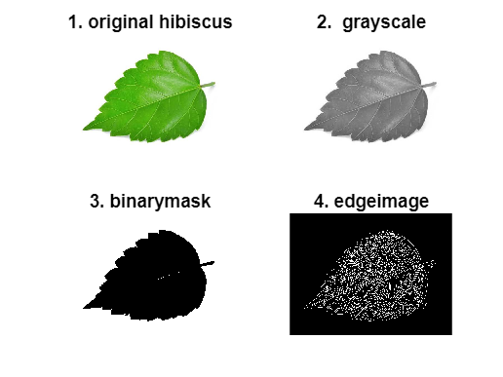
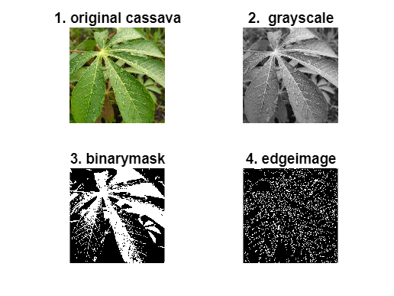

Chapter 3:

Conclusion and Learning Experience

This assignment has helped us to acquire knowledge and experience that helped us understand MATLAB programming concepts and gave us experience with the foundations we had acquired from Modules one to five. This project successfully demonstrated the use of MATLAB for basic image processing and classification of hibiscus and cassava leaves. The botanical characteristics of both leaves were stored using MATLAB structures, while their images were processed through grayscale conversion, contrast adjustment, thresholding, binary mask generation, and Canny edge detection. Generally, this assignment provided a practical foundation in data management and problem-solving within a computing environment.

Chapter 4:

References and Resources

- GOOGLE.com - source for the dataset used in question one.
- MATLAB Documentation - Used for syntax and function guidance on readtable() subplot() threshold2()fprintf()
- Computer programming lecture notes.

